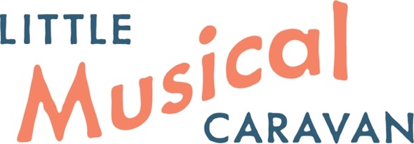

**Newsletter December 2024**

[www.littlemusicalcaravan.co.nz](https://www.littlemusicalcaravan.co.nz/)

Tag line: Mobile music therapy service

It has been another big year of change and growth for the Little Musical Caravan. Our base, Mana Therapy Hub, continues to grow, we have welcomed a new music therapist to the LMC and expanded our work, visiting new schools and forging new connections within our community. And we have more projects and partnerships in the pipeline… 2025 looks set to be another busy year!

**Partnership with Āhuru Mōwai Trust**

Our music therapy ‘taster’ sessions in partnership with [Āhuru Mōwai Trust](https://ahurumowaitrust.org.nz/) continue to be very successful. In July we ran a survey to gauge whānau responses to this service, and these were overwhelmingly positive. You can read the full report here: [LMC and AMT 2024 Report](https://www.littlemusicalcaravan.co.nz/wp-content/uploads/2024/10/Report-June-2024.pdf).

*Parent comment: “Thank you for providing our child with these sessions and even better helping with funding. This is something we would struggle to pay for normally but Ahuru Mowai makes it affordable for us and we are grateful. We hope these continue to be available for many other children and families to enjoy!”*

‘Taster’ sessions will continue at Awesome Bounce in 2025 and we look forward to another year supporting this awesome community. If you know a family who have not tried music therapy before, invite them to get in touch! [Awesome Bounce ‘taster’ sessions](https://littlemusicalcaravan.co.nz/ahuru-mowai-trust-registration/).

**Inclusive Playground Project:** In addition, you may have seen on social media that Āhuru Mōwai Trust is currently exploring the development of an Inclusive Play Space here in Porirua, in partnership with Porirua City Council and Plimmerton Rotary. Many of our LMC whānau were involved with the initial user survey, providing Lived Experience to guide playground design, and our Director, Emily, has been involved with the initial Project Advisory Group. The next stage, fundraising for the project, kicks off in early December with a Gala Dinner held at Te Rauparaha Arena in the first week of December. Please support this fundraising initiative if you can: An Inclusive Play Space, designed to support our tamariki and rangatahi with sensory differences, communication and cognitive challenges and/or physical challenges would be quite life changing for some of our whānau.

**Host Schools**

A big thank you also to our 2024 Host schools: St Theresa’s School, Plimmerton; Adventure School, Whitby; Porirua Montessori Primary School, Whitby; Raumati South School, Raumati; Greenacres School, Tawa; Redwood School, Tawa; Maraeroa Kindergarten, Cannons Creek. It has been a pleasure working with you to support your ākonga.

**Welcoming Marianne**

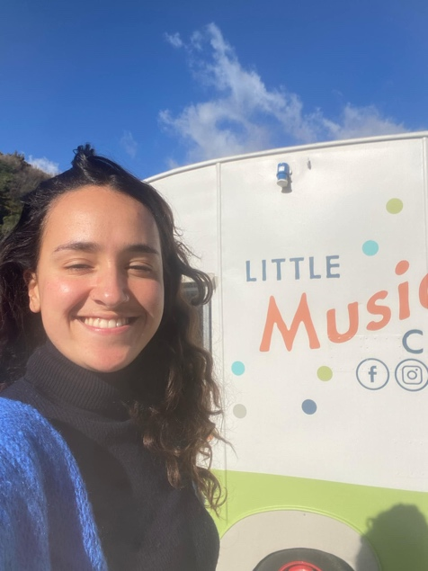

Music therapist Marianne joined us this year as a recent graduate from the Master of Music Therapy Programme at the New Zealand School of Music, Victoria University, Wellington. She brings a contagious joy to her work and it has been such a pleasure welcoming her to the Little Musical Caravan team. Many congratulations to Marianne on her graduation ceremony on 12th December!

**Congratulations to TJ**

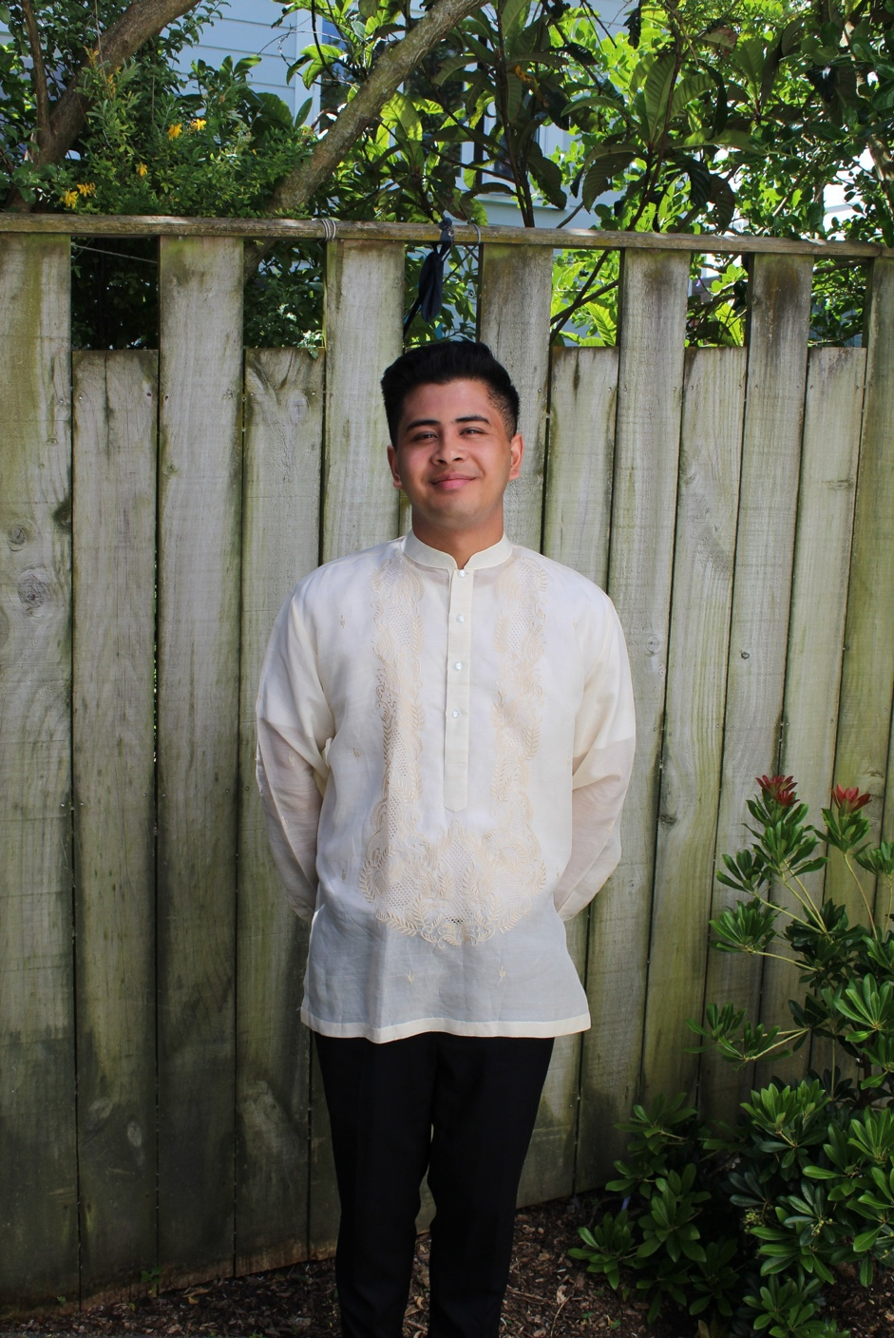

TJ presented at Music Therapy New Zealand’s 50th Anniversary Conference in September. The paper, based on his master’s thesis, was titled: *“Where are you from?” - navigating oppression, power, and privilege in music therapy spaces: A critical autoethnography on intersectional identities.* TJ has also recently taken on a Team Leader role with the LMC, and will be assisting next year as Clinical Liaison for our very first music therapy student.

**Behind the Scenes with Emily**

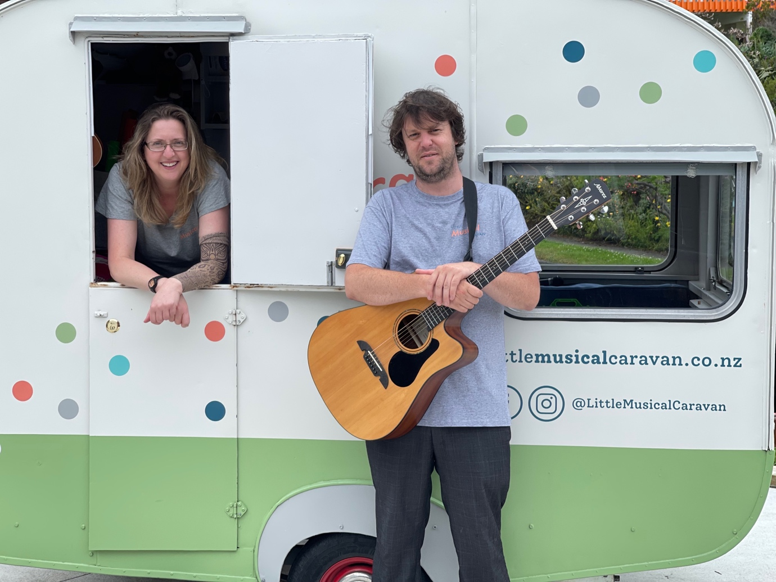Earlier in the year, Emily was appointed as Co-Editor of the *New Zealand Journal of Music Therapy* ([*NZJMT*](https://www.musictherapy.org.nz/journal/)). This is a peer-reviewed, online, open access, scholarly journal published annually by Music Therapy New Zealand for music therapists, students, allied professionals and others interested in music therapy.

As part of music therapy week, she talked to Bryan Crump on RNZ Concert about the Little Musical Caravan, her journey to create the space and the work we do. You can read and listen to that here: [The Mobile Music Therapist](https://www.rnz.co.nz/concert/programmes/three-to-seven/audio/2018933732/the-mobile-music-therapist).

For health reasons, Emily presented virtually, via slides and audio recordings, at Music Therapy New Zealand’s 50th Anniversary Conference alongside music therapy colleague and fellow long hauler Megan Glass with a paper exploring their Lived Experience of chronic illness through a post-ableist lens: *And then came Covid. Living and working in the grey: The lived experience of two music therapists with Long Covid.*

In addition, Emily has been involved in a number of other academic, accessibility and advocacy roles this year, like the Inclusive Playground mentioned above. Equitable access and sustainable funding for our communities to access the services they need has been a primary focus.

**Kindy Play-based Project with Liz**

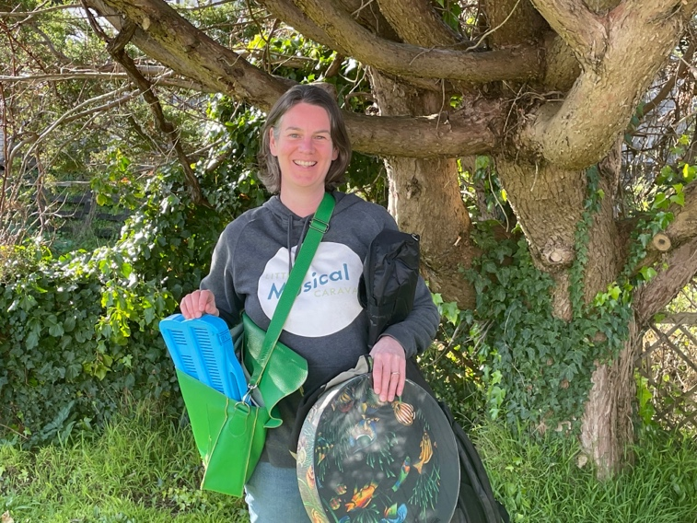

This year, Liz has been visiting Maraeroa Kindy in Cannons Creek to offer all-comer play-based music therapy sessions to their ākonga. Our child-led and strengths-based approach is a good match for the Kindy’s mahi and we are delighted with how these sessions are going. We will be updating our website with further information about this project in the next few weeks.

We also offer workshops and consultancy services for ECE and primary school teams to support educators to use music with their ākonga in a therapeutic way. If this is of interest for your kura, please [contact us](https://www.littlemusicalcaravan.co.nz/contact/).

**Funding challenges**

Individualised Funding (IF), which is used by many of our whānau to access our music therapy services, came under threat this year with sudden cuts and freezes and repeated moving of goal posts. Comms from Whaikaha – Ministry of Disabled People were confusing and at times upsetting for our communities. The LMC worked successfully with a number of families to challenge decisions about cutting music therapy services and as we close 2024, music therapy is still funded under IF. Guidance is that music therapy, whether treated as an activity that provides respite or as a form of therapy, are covered by IF as they are not considered to fall within another agency’s funding responsibilities. We’re aware that this may change again, but this is how things stand at the end of the year.

We stand in solidarity with our Australian colleagues and the Australian Music Therapy Association who are facing even more significant challenges to funding for families under their National Disability Insurance Scheme (NDIS). Advocacy for the rights of our disabled communities to access the supports they need will need to be ongoing, both across the Tasman and here in New Zealand.

**Summer Sessions**



We are again offering some limited spots for sessions at Mana Therapy Hub over the summer. If you have already expressed an interest in sessions for your child, I will be in touch shortly. Otherwise, bookings via the *My Music Staff* parent portal will be available from the 16th December. Term 1 will start for the Little Musical Caravan on Monday 3rd February 2024.

**2025 Fees and Travel**

Our fees for 2025 will remain at $85 + GST for 30 min individual sessions and $450 + GST for music therapy assessments. However, for greater transparency this will be displayed on our website and policy documents as GST *inclusive*: $97.75 (incl GST) and $517.50 (incl GST). Additional written reports are charged by the hour at $115 per hour (incl GST). Please contact us for a quote for group sessions, all-comer play-based sessions, workshops and school consultations.

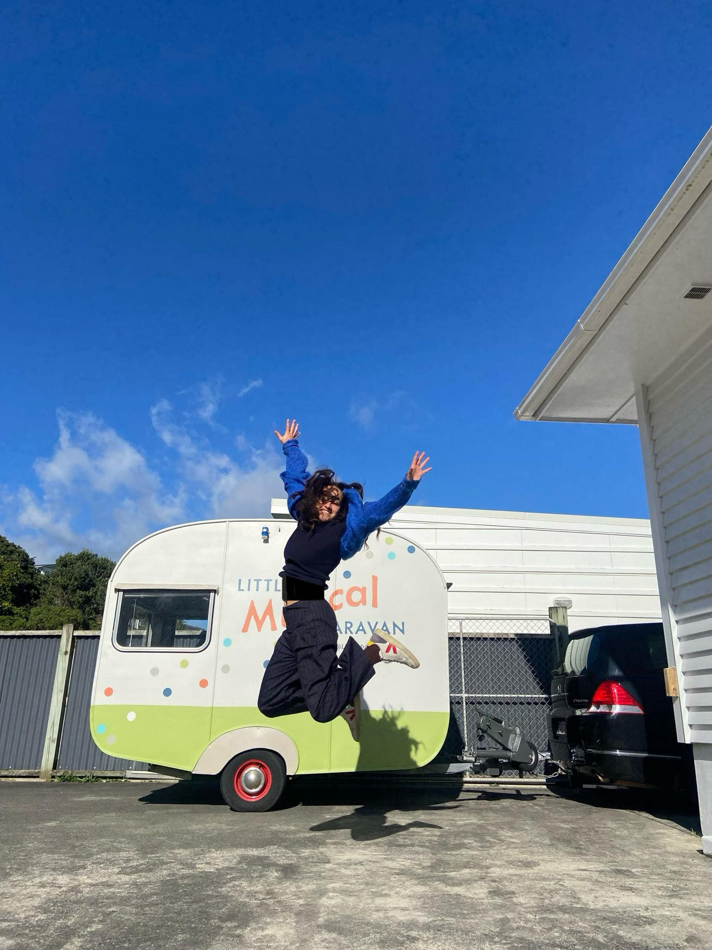

Travel will be charged at the current IRD rate of $1.04 per km. Wherever possible, when we are making trips to the same area we will adjust our scheduling so we visit one school site and then another, spreading the cost of travel between families. Where we are visiting 3 or more children on a school site within a 7 km radius of Mana Therapy Hub (a 14 km round trip) we will absorb the cost of travel. For all other families we visit outside the Hub there will be a charge.

**Instrument Donations**

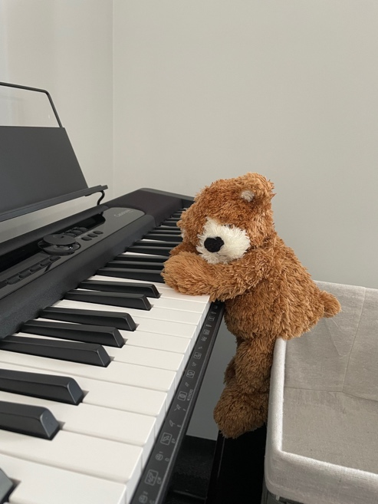

We have been very fortunate this year to be the recipients of a number of instrument and toy donations, including a djembe, a piano stool, an autoharp, a ukulele, a selection of hand held percussion instruments and a brand new keyboard. This really helps us in our work, especially as we travel to more locations. If, in your pre-Christmas (or maybe post-Christmas if your household is like mine!) clear out you find instruments which are looking for a new lease of life, please consider donating them to the LMC.

**Looking forward to 2025**

We have lots of exciting things lined up already for next year! There will be some organisational changes, with new email addresses to make it easier to contact our team. We welcome our very first music therapy student Max, who will be on placement with the LMC for the final year of his Master of Music Therapy degree. We are also delighted to have secured funding from [*Music Helps!*](https://www.musichelps.org.nz/) for a pilot project partnering with [Te Whare Tiaki Wāhine Refuge (Porirua)](https://www.tiaki.org.nz/). The pilot project will offer group sessions to support wāhine and their pepi and tamariki who have experienced Family Violence. We will also be celebrating our 5th Birthday partway through 2025! Check our website and Facebook page later in the year for information about our celebrations!

**Reminders**

* We have a dedicated parking spot for our Hub clients. Please use the number 3 parking spot where our ‘Little Musical Caravan’ logo is displayed. There is also parking available along the road (outside of clearway hours) and nearby at the train station.
* Invoices for ongoing therapy are sent at the end of each month for work done during the month with payment due within 14 days (unless you have a payment plan prearranged). Your prompt payment is appreciated so we can spend more time doing the music therapy and advocacy work we love instead of chasing missing payments!
* However, if you find yourself in financial difficulties, please get in touch asap so that we can work out a way to support you and your tamariki.
* We will be reviewing our cancellation policy to ensure that it aligns with our post-ableist values, and will communicate this with our whānau in the New Year, but we do have a 24 hour cancellation policy. Please give us as much notice as possible if you need to cancel a session.
* We work with a number of immunocompromised and vulnerable clients . For their health and our own, we ask that if your child is sick you keep them at home.