**Authentic Social Connection**

# Exploring ways of relating and caring for others

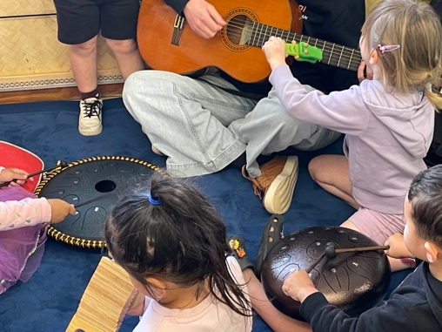

## Te Whāriki Strands

* Mana atua | Wellbeing
* Mana whenua | **Belonging**
* Mana tangata | Contribution
* Mana reo | **Communication**
* Mana aotūroa | Exploration

Te Whāriki, the Early Childhood Education curriculum, weaves together the different strands of learning which help children to develop the skills they need as they grow. These include wellbeing, belonging, contribution, communication and exploration. Music therapy is easily able to support these different learning areas with its holistic and relational approach. At Maraeroa Kindergarten, the staff put a big emphasis on creating authentic social connections by exploring different ways of relating and caring for others. This is evident in many ways and supported through the provision of weekly music therapy.

### **Learning Story: “I want to play guitar!”**

### Using music to develop communication skills and create a sense of belonging

Where: Maraeroa Kindergarten, Porirua

When: 22 November 2024

Who: Ākonga at Maraeroa Kindergarten and Liz Langham, NZ Registered Music Therapist with the *Little Musical Caravan*

### The Story

Liz: *I walk into the kindy, instruments swinging off my shoulders and my guitar slung across my back. I am barely through the doorway before several children start rushing towards me… I come at the same time every week and they know what to expect - musical fun together!*

*I barely have time to sit down and already a cluster of children have gathered around me. Some children have a very clear idea of what they want to do and quickly grab different instruments. Others usually take a while to observe before drawing closer. This morning, however, there is something magnetic about the guitar and I have three children all wanting to play it - on their own! Right now! Me first!*

*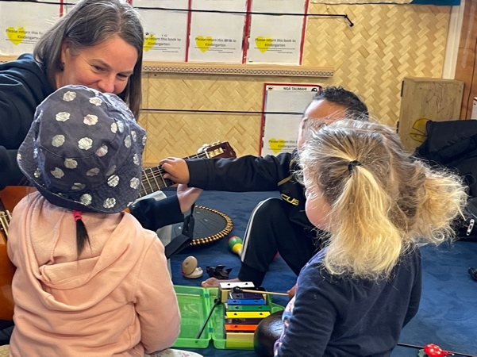One is trying hard to strum the strings, another is placing their hand over the strings to stop the sound. The third child is looking on with curiosity, clearly wanting to join in but not sure how best to do so. Ah... this is a challenge for all of us to negotiate. Two of the children are getting quite heated, perhaps worried that they won’t get the turn they are wanting. I choose to stay calmly holding onto the guitar and smile at them all, simply saying ‘it’s ok, we can wait together.’ I want to see how the children will work things out.*

*Although it is a bit uncomfortable for all of us for a minute as we wait together, it creates time for each person to think about how they get what they really need. One person decides that they just really want to make music alongside their friends and so they take up the suggestion of playing a tone drum beside us. The tension lessens a little. Meanwhile, other children come and start experimenting with the other instruments I have provided around us. We start to hear beats on a drum, wooden clackers and the gentle sounds of  chime bars. As I gently but firmly hold the guitar, I am able to encourage these other musicians in their playing with my voice and smiles.*

*Back at the guitar, however, two people are still locked in a battle of wills, both wanting to be first to play it. I gently remind them that there will be enough time for everyone to play and that I am happy to wait until they can work it out.*

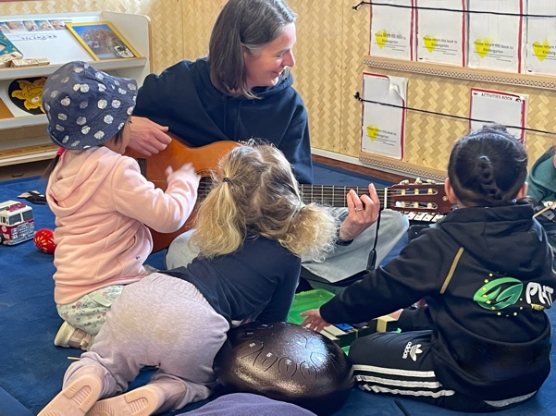

*As the music of their friends starts up around them, perhaps they realise that by wanting to be first, both of them are actually missing out! This leads to the children loosening their grip on the guitar and starting to look around for other opportunities. After a while, they decide that they can both strum the guitar at the same time whilst I change chords to create different sounds. Later, they take turns. By practicing a ‘pause’ together, we all find a way to create harmony.*

Interpretation

**Communication** comes in many forms and music is a form of communication in its own right, allowing for connection without the need for words. In this learning story, the communication that Liz describes from the children is mainly non-verbal, with gestures and body language playing a central role. The children express their needs and wants through their actions – through their eagerness to play the guitar, the way they observe and interact with each other, as well as how they experiment with different ways of playing.

Liz also provides some positive modelling for the children. She demonstrates active listening as the children express their frustrations about wanting the guitar, offering a calm presence and validating their feelings. Her verbal cues “it’s ok, we can wait together” and ‘there will be enough time for everyone to play” guide the children to reflect on the situation and communicate indirectly with one another. She also creates space for them to find solutions for themselves, fostering an empathetic way of engaging and negotiating with others.

Fostering a sense of **belonging** is reflected in how the children shift from their individual desires (fighting for the guitar) to collaborative play. Initially, they are focussed on what they want – to be the first to play the guitar – but as the group dynamic changes, they realise that they can all participate in the experience. The moment where one child switches to the tone drum as other children experiment with different instruments, suggest a feeling of inclusivity and shared purpose. By working through the challenge and reaching a compromise, the children find their place within the group. This fosters a sense of belonging, where everyone is respected and valued, not for playing the guitar first, but for their role in creating harmonious music together.

Musical play provides a platform for the children to **communicate** and feel a sense of **belonging** but also actively promotes **equitable collaborative play** and the development of **negotiation skills**. The challenge over the guitar becomes an opportunity for the children to **negotiate**, **compromise**, and **collaborate**, all within the context of a shared musical experience. This interaction teaches them that collaboration isn’t about winning or being first, but about creating something together that’s larger than any one individual. Music serves as both the **common language** and the **framework** for developing these essential social skills, setting the stage for more harmonious and cooperative play in the future.

Kaiako Comments

*These sessions are seen as a social hub, a safe place for children not only to engage in music, but to practise the skills needed to relate and engage with others. We are practising seeing other points of view, negotiation of sharing, modelling, and non-verbal communication as we share the instruments and collaborate in music-making. Children have the opportunity to come and go as they please, so we are able to see the joy of them coming together for a shared purpose in community with each other. With time and practice, it is wonderful to see them meaning-making alongside and with their peers.*